Task 3 Week 3
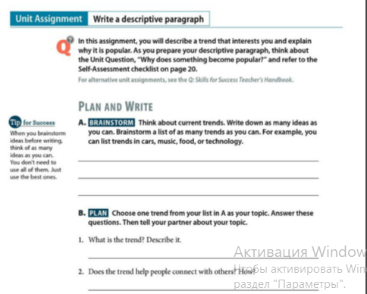
Write a descriptive essay on the topic “Why does something become popular?”

